Information on tourist spots around Ojiya

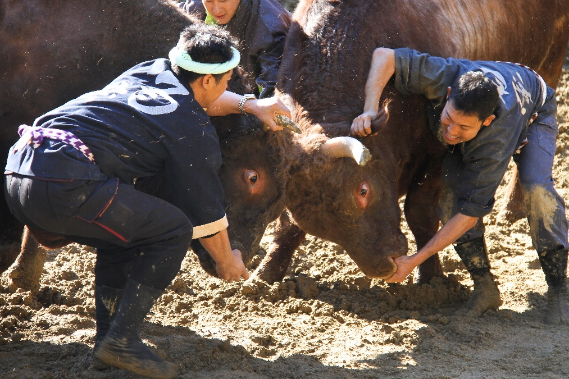
Bullfighting

Bullfighting is one of the traditional cultures of Ojiya. The origin of bullfighting is unknown, but in a famous novel from the late Edo period, a story about bullfighting in this area is written. There is a theory that bullfighting is a religious event dedicated to Mt. Kanagura located in this district, and it is a custom to end a fight in a draw.
The bullring is located in a mountain area called Higashiyama. The bulls weigh 700 kilograms to 1000 kilograms, and they are eligible for a fight from three-year-old. From May to November, it takes place on the first Sunday of each month except August. During the season, many people come from all over Japan and foreign countries.
Highlights of a fight are not just its powerful fight of big bulls, but also a commentary and a person who stimulate bulls and make the intense fight a draw without any injuries. Bull owners raise a bull as a family, and it is interesting to see a bull taking a walk.

